FOR IMMEDIATE RELEASE
Greater Houston Women's Chamber of Commerce Celebrates
Unveiling of Charlotte Baldwin Allen Statue
HOUSTON, TX | March 19, 2026 | Women's History Month

The Greater Houston Women’s Chamber of Commerce proudly hosted the unveiling of a bronze statue honoring Charlotte Marie Baldwin Allen, co-founder of Houston, during a special reception in the garden of the historic Julia Ideson Building at the Houston Public Library. The tribute was held during Women’s History Month and as the Julia Ideson Building marked its centennial, creating a powerful moment to recognize a woman whose leadership and investment helped shape the city from its earliest days.
Charlotte Baldwin Allen is increasingly recognized as one of the most important figures in Houston’s founding. Her inheritance was used to purchase the half league of land along Buffalo Bayou in August 1836, laying the foundation for what would become the City of Houston. She later lived in Houston for more than half a century, built land and enterprise, and left a legacy of vision, courage, and determination that continues to resonate across generations.
The event featured remarks from Mayor John Whitmire and Suzan Deison, Founder, President, and CEO of the Greater Houston Women’s Chamber of Commerce. Mayor Whitmire and Deison also joined together to officially unveil the statue. Mayor Pro Tem Martha Castex-Tatum presented a proclamation from the City of Houston declaring March 19, 2026, as Charlotte Marie Baldwin Allen Day in Houston, Texas, honoring her enduring impact on the founding, growth, and future of Houston.
Deison said the unveiling represents a long-overdue public recognition of a woman whose role in Houston’s origin story deserves permanent visibility. She noted that Charlotte Baldwin Allen’s example reminds the community that women have always been builders of cities, economies, and institutions, even when history has not always given them equal credit. The monument, she said, is intended not only to honor the past but also to inspire future generations of women and girls to lead with confidence and purpose.
This historic commemoration was made possible through the Greater Houston Women’s Chamber of Commerce, under the leadership of Suzan Deison, together with CREW Houston, Women of NAIOP, the ULI Women’s Leadership Initiative, the Julia Ideson Building Board, the Houston City Council, and the Mayor of Houston. The project reflects a shared commitment to preserving Houston’s history and elevating the stories of women whose contributions have too often been overlooked.
By placing Charlotte Baldwin Allen’s likeness in a prominent public setting, the statue ensures that her story will be visibly remembered and honored for generations to come. The Greater Houston Women’s Chamber of Commerce and its partners hope the monument will encourage Houstonians to celebrate Charlotte Baldwin Allen not only as a founder, but as a lasting symbol of leadership, foresight, and civic impact.

About the Greater Houston Women's Chamber of Commerce  The Greater Houston Women’s Chamber of Commerce is the largest women’s chamber in the country and is dedicated to advancing women and empowering businesses through leadership, advocacy, education, and strategic connections. | Media Contact  Suzan Deison  CEO/President/Founder  Greater Houston Women’s Chamber of Commerce  713-782-3777  info@ghwcc.org
Greater Houston Women's Chamber of Commerce

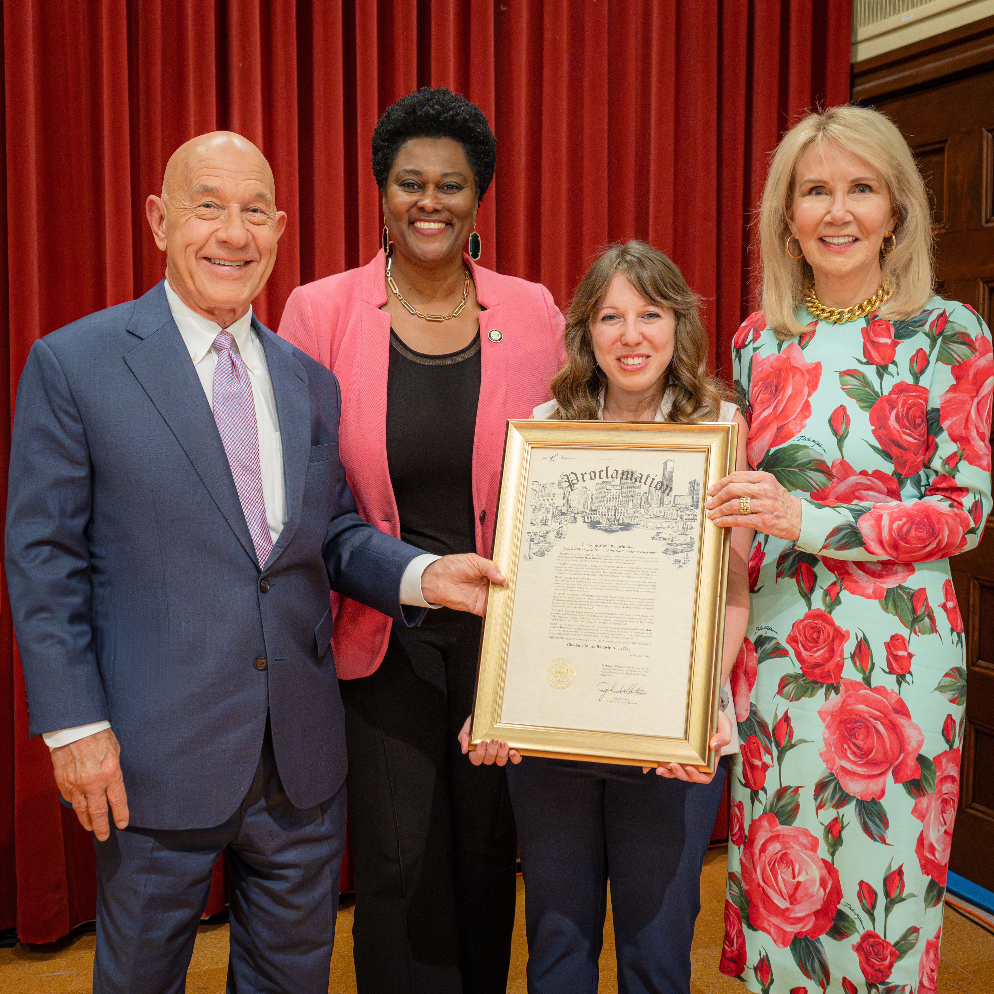
Left: City of Houston Mayor John Whitmire, Mayor Pro-Tem Martha Castex-Tatum, Vice Mayor Pro-Tem Amy Peck & Suzan Deison

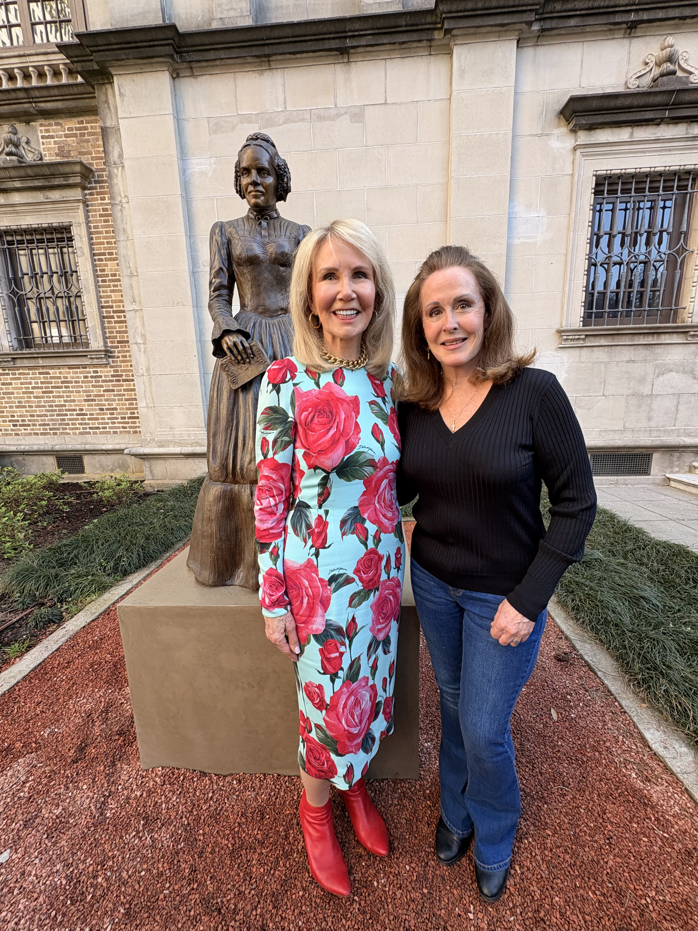
Left to Right: Suzan Deison & Lori Betz

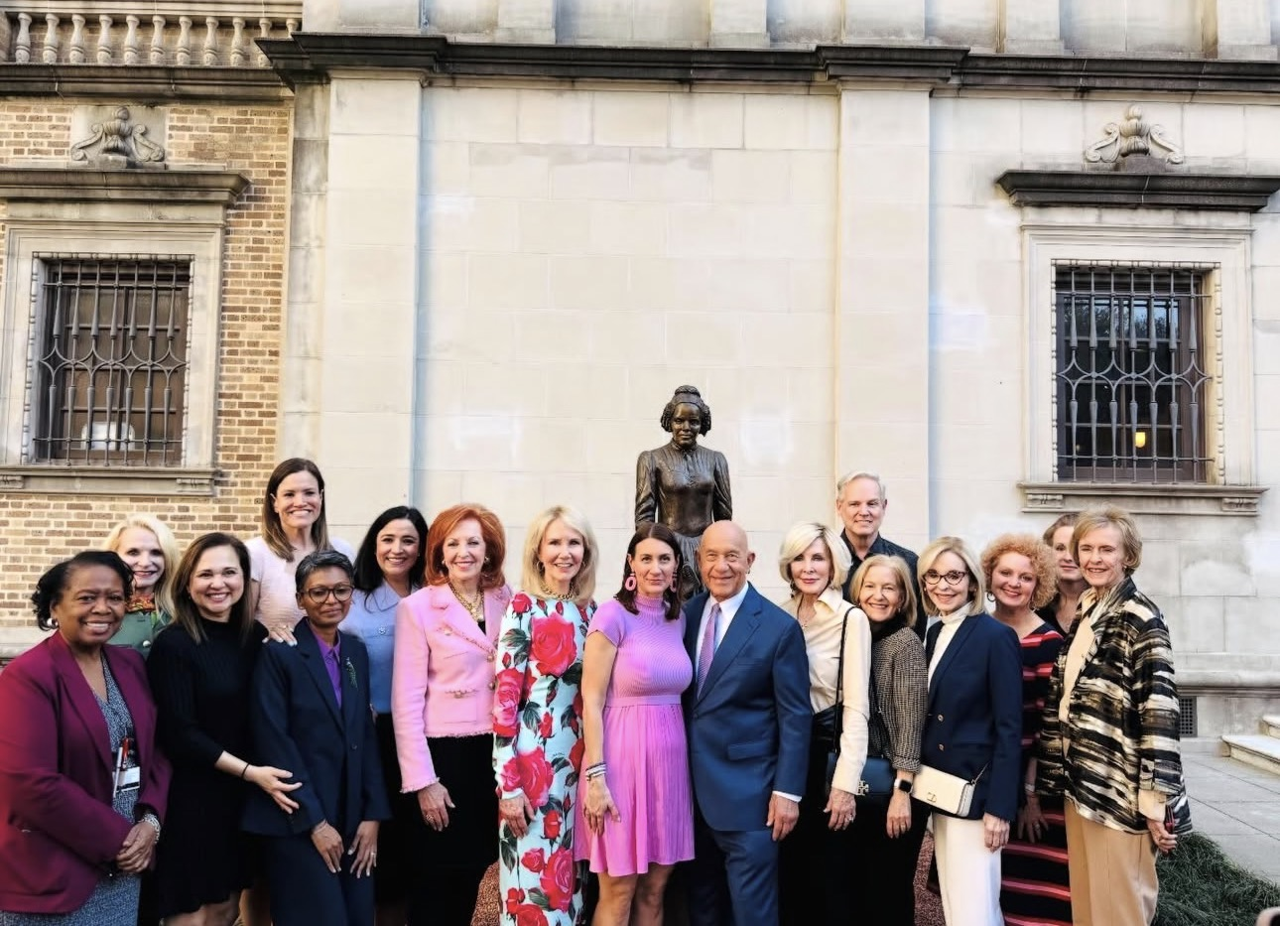
Left to Right: Mary Benton, Traci Pelter, Elizabeth Gonzalez Brock, Lindsay Munoz, Meena Palanivelu, Maria Martinez, Nancy Strohmer, Suzan Deison, Whitney Whitmire, City of Houston Mayor John Whitmire, Dr. Mary Ann Wilkins, Doug Parker, Theresa Einhorn, Sandra Porter, Jeanna Bamburg, Lori Betz & Toni Lawrence

