For Immediate Release

**Contact: Chelsea McGruder, Director of Events & Communications | Email: cmcgruder@ghwcc.org | Phone: 713-782-3777**

# Greater Houston Women’s Chamber of Commerce, International Women’s Chamber of Commerce–Mexico Chapter, and CCE Mexico Host First Leadership Summit for Women in Mexico

Houston, Texas – September 29, 2025 – The Greater Houston Women’s Chamber of Commerce (GHWCC), in partnership with the International Women’s Chamber of Commerce–Mexico Chapter and CCE Mexico, recently hosted **the first-ever Leadership Summit for Women in Mexic**o, a historic gathering dedicated to empowering women and advancing global leadership.

The Summit, chaired by Soraya Cervantes, co-founder IWCOC- Mexico Chapter welcomed nearly 450 participants in a standing-room-only event. The program highlighted women leaders across business, government, and innovation, united under the theme: **“Power in Unity: Accelerating Women Globally.”**

Throughout the day, distinguished speakers and panelists explored how women are shaping trade and innovation, transforming executive culture, governing with purpose, and driving bold entrepreneurship. A special tribute was also paid to Mexico’s Women of Excellence, honoring trailblazing leaders recognized for their national impact.

Suzan Deison, CEO/President/Founder of the GHWCC and IWCOC, shared:  
**“This Summit proved that when women come together across borders, we ignite real change. I am grateful to our U.S. delegation and our incredible leaders in Mexico—your vision and leadership inspire women around the world.”** – Suzan Deison, CEO/President/Founder, GHWCC & IWCOC

The GHWCC delegation included distinguished leaders whose presence and contributions helped to make this global outreach successful:

* **Mayor Pro-Tem Martha Castex-Tatum, City of Houston, joined by her Chief of Staff Perdita “Didi” Chavis and Deputy Chief of Staff Justice Coutee-McCullum.**
* **Houston City Council Member Tarsha Jackson, and her Chief of Staff Mary Moreno**
* **Kim Coomber Hallum, bp & GHWCC 2025 Chair of the Board**
* **Maria Martinez, Murphy Oil Corporation & GHWCC 2024 Past Chair of the Board**
* **Theresa Einhorn, Former Partner, Haynes Boone**
* **Nancy Strohmer, Entrepreneur and Philanthropist**
* **Dr. Caroline Levander, Rice University**
* **Diana Candelaria Reyes, Candelaria Reyes Consulting**
* **Bery Crispin, A Sacred Choice Funeral Home**
* **Mariana Tapia, Hines**
* **Chelsea McGruder, GHWCC, IWCOC**

This landmark event not only strengthened international partnerships but also inspired collaboration among women leaders to accelerate progress globally.

## About the Greater Houston Women’s Chamber of Commerce

The GHWCC and the IWCOC are nonprofit organizations dedicated to advancing women through leadership, education, advocacy, and mentoring. With chapters across the globe, the Chamber is committed to building an inclusive future where women and girls have visibility, voice, and equal opportunity to lead.

**Supporting Photos:**

Elena Palacios, Priscilla Zozaya Segura, Jessica Braver, Cynthia Saide, Soraya Cervantes, Suzan Deison, Mary Moreno, Kim Coomber – Hallum, Theresa Einhorn, Houston City Council Member Tarsha Jackson, Chelsea McGruder, Bery Crispin, Perdita “Didi” Chavis, Justice Coutee-McCullum, Houston City Mayor Pro-Tem Martha Castex-Tatum, Maria Martinez, Diana Candeleria Reyes, Caroline Levander & Nancy Strohmer

Elena Palacios, Suzan Deison & Soraya Cervantes

Heberto Guzmán, Elena Palacios, Suzan Deison, Soraya Cervantes, Felipe Haro Poniatowski, Nora Ricalde Alarcón, Rodrigo de la Sierra & Francisco Cervantes Diaz

Houston Mayor Pro – Tem Martha Castex Tatum, District B

Francisco Cervantes Diaz, President of Mexico’s Business Coordination Council (CCE)

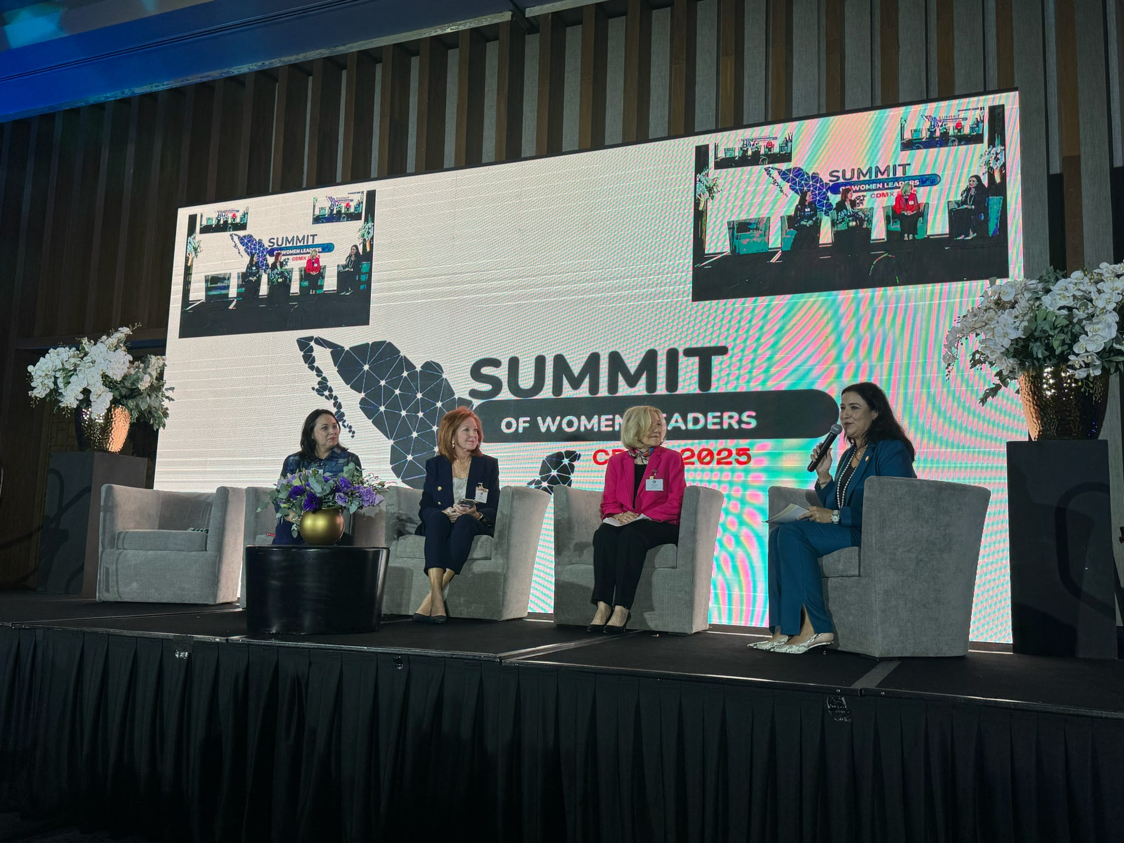

Diana Candeleria Reyes, Nancy Strohmer, Theresa Einhorn & Maria Martinez

Max El Mann Arazi, Manuel Pérez Cárdenas, Grace Rojas Montemayor, Frederic García & Brenda Olivas

Houston City Council Member Tarsha Jackson, Caroline Levander, Kim Coomber-Hallum, Maria Elena Arande & Maria Martinez

Suzan Deison, Rodrigo de la Sierra, Soraya Cervantes & Francisco Cervantes Diaz

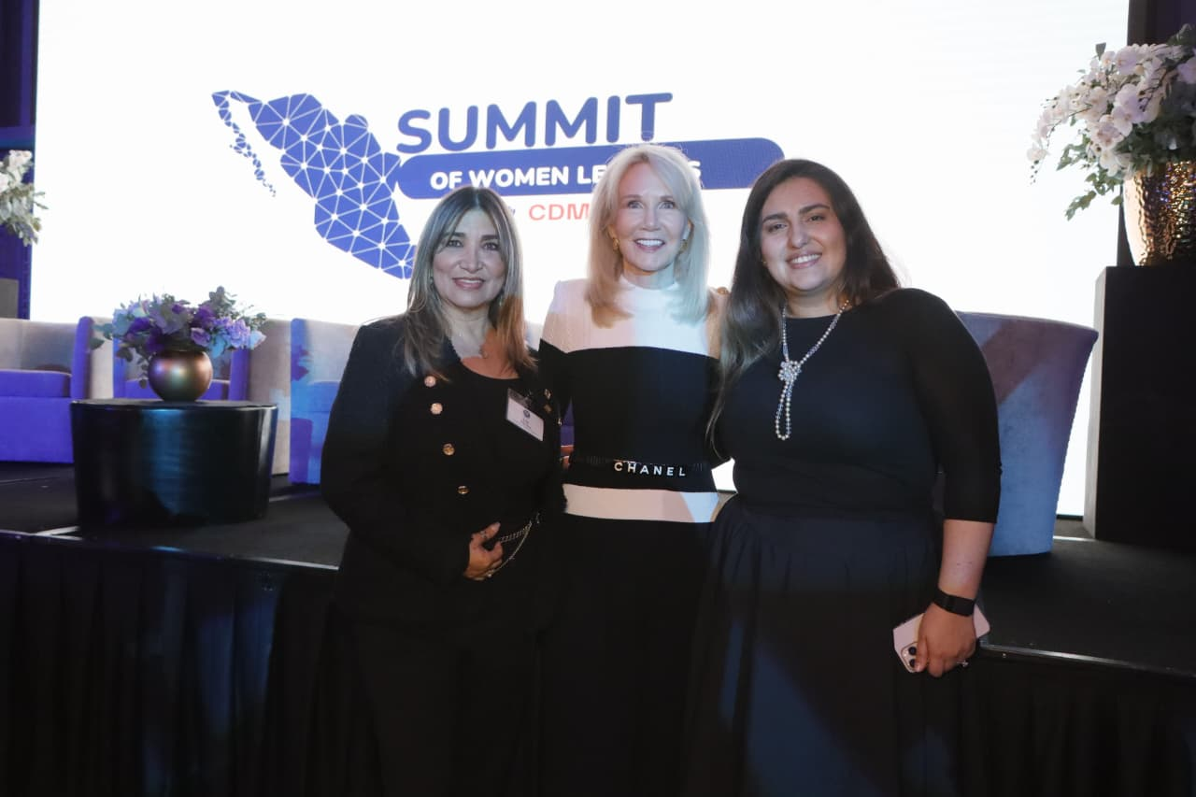

Lily Ramírez, Suzan Deison & Soraya Cenrvantes